Infusing creativity into the P4 writing curriculum

School-based project report
Writer: Dr Cecilia Chu
Uploaded in 2014 on LLSS website

Accessed on 24 March 2015:
http://cd1.edb.hkedcity.net/cd/languagesupport/article/english/writing/writing14/index.htm

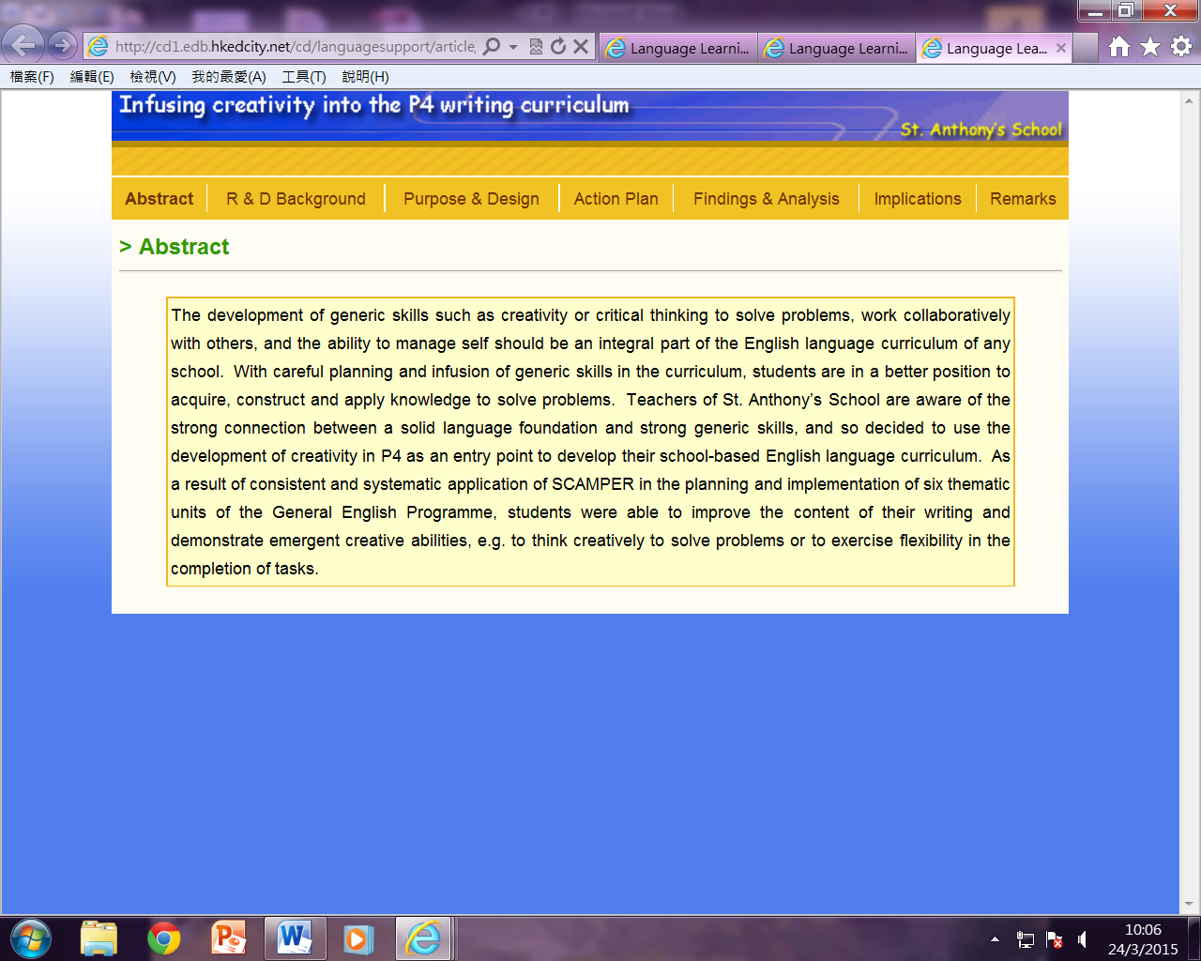

Abstract
The development of generic skills such as creativity or critical thinking to solve problems, work collaboratively with others, and the ability to manage self should be an integral part of the English language curriculum of any school. With careful planning and infusion of generic skills in the curriculum, students are in a better position to acquire, construct and apply knowledge to solve problems. Teachers of St. Anthony’s School are aware of the strong connection between a solid language foundation and strong generic skills, and so decided to use the development of creativity in P4 as an entry point to develop their school-based English language curriculum. As a result of consistent and systematic application of SCAMPER in the planning and implementation of six thematic units of the General English Programme, students were able to improve the content of their writing and demonstrate emergent creative abilities, e.g. to think creatively to solve problems or to exercise flexibility in the completion of tasks.

R & D Background

Creative thinking is one of the generic skills advocated in the local English language Curriculum Guide. Teachers may plan for creativity development as it refers to abilities, attitudes or attributes, and by using and applying problem solving models. It is important that we start planning and developing the generic skills early in the primary school education.
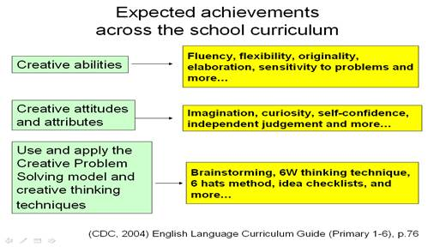
The ability to think creatively is pivotal to the successful completion of any well-designed language task. For example, to make a story stand out against the crowd, teachers may guide students to develop creative fluency, or the ability to produce many interesting and varied ideas through visualisation and elaboration.
In addition to fiction, students are asked to write non-fiction texts. These can range from procedural texts, e.g. recipes, directions, to persuasive texts, e .g. advertisements, proposals. In all these, the ability to define problems, take different perspectives, borrow ideas from one context and use them in another or see ‘new’ meanings in ‘old’ notions, are essential creative skills that students need to be able to master and demonstrate confidently. Teachers should ensure the school-based curriculum pays due attention to how creative thinking might best be developed.
Developing creativity should not be seen as an add-on or extra programme. In order for it to be developed and nourished effectively, it needs to be part of the regular, daily teaching, and it needs to be encouraged by teachers. With this in mind, teachers of St. Anthony’s School were guided by the following principles, extracted from their literature review on this topic:
1 | Thinking builds on existing knowledge: it is necessary to help students from mastering knowledge to generating knowledge
Knowledge is an important factor as there is a very close relationship between a person’s knowledge and a person’s ability to be creative (Weisberg, 1999). Kaufman & Baer (2006) emphasise that effort, practice, and study are necessary for the highest levels of creative accomplishment. So there is a close relationship between creativity and background knowledge of the different themes covered in English lessons. It is important to give students sufficient input about the topics covered before assigning a language task.
2. | Students can learn faster with a tool of creative thinking
A common tool used to develop creativity is SCAMPER. Eberle (1977, 1996) adapted Alex Osborn’s (1953) idea-spurring queries and arranged them into an acronym SCAMPER, which stands for:
- Substitute.
- Combine.
- Adapt.
- Modify.
- Put to another use.
- Eliminate.
- Reverse.

Source: Curriculum Development Institute, Education Bureau (2012). Nurturing pupils’ creative thinking in the upper Primary English classroom. Hong Kong: Author. pp.20-21
One may use each of the seven prompts to ask questions about problems or challenges in a wide range of situations (business or personal life). When designing English language tasks, teachers at St. Anthony’s School used this tool constantly and systematically throughout the year.
3. | Persistent practice instead of one-off activities facilitates the formation of creative thinking habits
 | By routinising the infusion of work on creativity into the curriculum, teachers can help students develop the ability and make creativity thinking as part of their life. Therefore, teachers should plan and implement constantly and systematically.
4. | A suitable classroom atmosphere that is conducive to learning and encourages students to take risks
 | The UK Office for Standards in Education (OFSTED, 2010) studied how 44 schools used creative approaches to learning. Those schools inspected had aspirations for their pupils to ask questions independently, make connections between ideas, think creatively, challenge and participate effectively etc., all of which have impact on students’ personal growth. In the English learning classroom, if teachers want to nurture the ability to think creatively, they should be creative teachers as well. Teachers should reconceptualise their classrooms as creativity hubs full of interesting and diverse language tasks, in which students feel free to take risks, express wild ideas, and derive enjoyment form the process of achieving higher levels of language competence. Teachers should give appropriate levels of praise and rich, relevant useful feedback to sustain the interest of students in working creatively.

Purpose and design

Topic
Using SCAMPER as a tool to develop creativity in writing
Level
Primary 4
Objectives
● | To enhance students’ ability to think creatively about the range of topics covered in their English lessons
● | To develop students’ ability to display features of creative thinking in their writing
Strategies used
In the design of the writing tasks given to P4 students, the teachers took great care to ensure a balanced coverage of the different generic skills but decided to single out the development of creative thinking for close observation. The teachers tried to help the students develop 3 creative abilities: originality, flexibility and provide creative solutions to problems. They felt that their decision to use a tool that was new to them (SCAMPER) required close monitoring so the potential impact and benefits could be better evaluated. The strategies related to the use of SCAMPER in writing included:
● | Use of a wide range of readers and other sources of input alongside the book used in the General English programme to build/ strengthen students’ background knowledge of the topics covered;
● | Development of open-ended tasks that give students space to use their imagination and think creatively;
● | Consistent and systematic use of SCAMPER as a tool to help students approach topics, issues, problems and tasks creatively and contribute to the development of a learning atmosphere that encourages students to take risks and think outside the box;
● | Use of task-based learning framework to ensure coherence in learning and a balanaced and integrated coverage of the four language skills.

Action plan

How did the teachers infuse the systematic development of creativity into the curriculum?
In the General English programme, each module was set on a theme and included a choice of relevant readers.The teachers designed some purposeful writing tasks for the students. The three stages of the module units are shown in the table below.
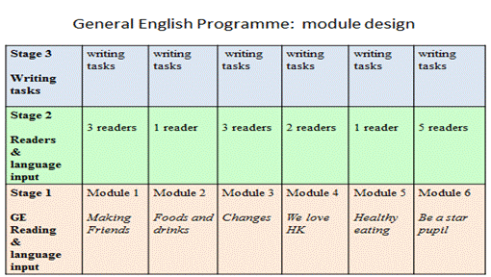
At stage 1, the students were guided to broaden their knowledge base of the theme through studying the textbook passages of each unit.
At stage 2, students were guided to appreciate the stories in the readers and explore various aspects of the stories. This stage aimed at providing scaffolds for students to develop the content of writing. The students would learn different aspects of the theme through studying the GE passages and readers. Besides, the teachers provided the students with new language input and knowledge of text type features using the module books the teachers had devised collaboratively based on grammar and vocabulary in textbook passages and readers.
At stage 3, the students were guided to attempt some writing tasks related to the theme with the use of SCAMPER. The writing tasks ranged from short and simple to more challenging writing tasks.
How did the teachers plan a unit and teach students to use SCAMPER to brainstorm in writing? Let us take a look at Module 4.
Module 4 : We love Hong Kong.
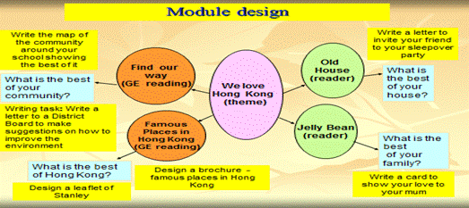
Based on this theme, the students were given different reading materials including textbook passages and readers. The students explored different questions (e.g. What is the best of your community? What is the best of your house?) in whole class discussion. They then attempted 4 writing tasks (e.g. Design a leaflet of Stanley)

Tasks | SCAMPER application
Writing 1- Write an informal letter to invite your friend to your sleepover party - introduce the best of your house (mainly the physical part) | ● Substitute  Replace the description of the house in the storybook ‘My House’ with their own bedroom description. They describe their bedrooms based on the appealing features found there.
Writing 2- Design a leaflet of Stanley - one of the famous places in Hong Kong after collecting data in a visit to Stanley | ● Combine  Combine the ‘history of Stanley’, ‘where to go’, ‘what to see’ and ‘what to do’ to form a brochure for tourists.  ● Minify  Summarize the history of Stanley in a short paragraph.
Writing 3- Write a brochure introducing famous places around Hong Kong. Include information about heritage and culture, shopping and dining.  You may use the Internet or other sources in your research. | ● Making connections among different attractions of Hong Kong and sort them into different categories according to the activities tourists can do.
Writing 4- Design a card to show your love to your mum | ● Put to other uses  The personal recount in the story was changed into a thank-you card to Mum .
Writing 5- Write a formal letter to Central and Western District Board to report the problems found in the neighbourhood/ district/ community and provide suggestions for improvement | ● All  Students apply SCAMPER
In Writing 2, in order to produce a leaflet about Stanley after collecting data during the Stanley visit, the students had to apply SCAMPER (combining and minifying) to handle the information creatively.
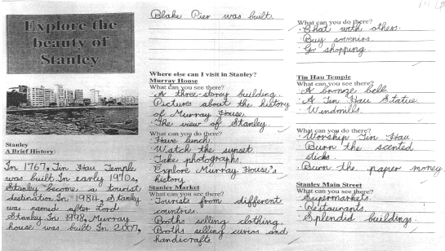
In Writing 5, the students studied the textbook reading passage ‘Famous Places in HK’, and other readers related to loving one’s family etc. Thus they were aware of the importance of a good environment for their daily life and their school. In a more challenging writing task, students needed to first observe the neighbourhood around their school and later come up with some suggestions to improve the environment. To make the writing task more authentic, the teacher asked the students to write a formal letter to the Central & Western District Council using the information they discussed in the lessons. The following shows the steps followed in the writing lessons.
To activate the students' ideas, the teacher first asked the students to think of their ideal neighbourhood by giving hints on a worksheet. Then the students worked in pairs and finally they expressed their views about what constitutes a good environment to the class. | The students were given some photos taken in the neighbourhood. They had to study the photos showing potential dangers and problems occurring in the environment. The students jotted down their observation on some post-its and stuck them on the photos for the next stage of the lessons.
The students worked in groups and took turns to present their problems identified. ;As there were so many problems and they could not handle all at a time, the teacher asked them to prioritise the problems by thinking which ones are more urgent and important. This is the core part of the task. Students then applied the thinking tool SCAMPER to brainstorm ideas for suggestions. | This thinking tool can offer them different ways to give suggestions to improve the environment. For example, they can construct something instead of the things exist (Substitute), cut the use of something (Elimination), increase the number of something (magnify).
The students were also introduced to the format and style of formal letters. | 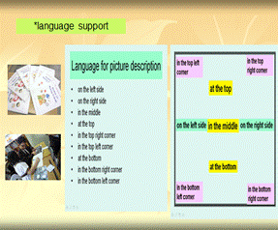
This student writing sample shows the application of SCAMPER. For example, Eliminate- to eliminate rubbish by throwing away fewer things. Modify- to change the outlook of the road (e.g. making the road wider) and the area (e.g. planting more trees and flowers), Magnify- to build more stairs at the footbridge, and increase the number of cafes and restaurants,</< td>

How did the teachers assess students’ creativity in writing? Let us take a look at Module 6.
Module: Be a star pupil
Before the start of the summer holiday, the teachers asked the students to devise a summer plan.
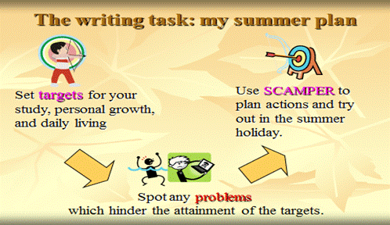
First, the students needed to define targets for improvement in study, personal growth, and daily living. Next they had to identify the problems that might hinder attainment of their targets. Finally they would apply the technique of SCAMPER to plan actions to overcome the problems.
This summer task aimed to encourage students to personalise the use of SCAMPER and realise that they can also approach daily tasks creatively. SCAMPER can help students generate new ideas and this helps them develop good content in writing. But the level of creativity may vary as the new ideas may be very unique or can be just practical, relevant and/ or useful. The teachers know that it is difficult to assess creativity as this is not as solid as other knowledge and skills such as grammar and computer skills. But based on the nature of this task, they tried to give feedback to students’ levels of creativity.
The teachers wanted to encourage students to use as many SCAMPER prompts as possible to generate ideas. And it is better if some of the ideas are really very special and unique. There are 4 levels of creativity: very creative, creative, routine, and to be improved. In order to be rated “very creative”, the student’s ideas have to be original, unique and uncommon and their ideas can inspire other people.
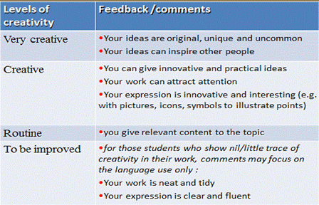
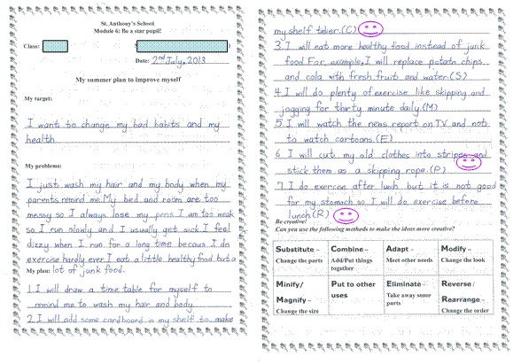
This is an example of a very creative plan. The student wanted to change her bad habits and improve her health. She identified many problems which hindered attainment of her targets. She used 5 SCAMPER strategies in her plan.
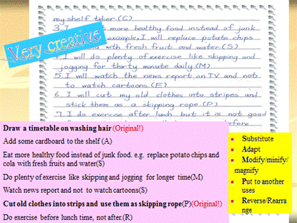
She suggested two very unique ideas in her plan. One is to draw a timetable for washing hair. Another one is to cut old clothes into strips and use them as a skipping rope.

Findings and analysis

To evaluate the project, teachers issued a questionnaire to the students to ask for their comments on the new P4 English learning activities. The teachers would like to know how much the students liked the writing tasks and the English programme. In the questionnaire, the students had to specify their favourite task or text type in each module. Then they chose some possible reasons. Throughout the year, the students had been asked to keep a reflection log in each module so the teachers also looked for relevant comments from the logs.
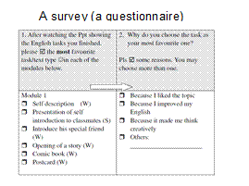 | 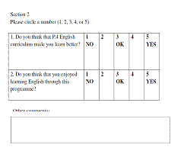
On the whole, the majority of students felt that the P.4 English curriculum helped them learn better and they enjoyed learning English through this programme. Besides, from the result of the questionnaire, teachers found out which ‘creativity’ tasks are more popular with students (drama script for performing in school hall, party planner, an article in our school magazine, a leaflet about Stanley, and a five-line poem) and this was useful for the enhancement of the programme.
One of the objectives of this project is to nurture students’ creativity. From the student’s reflection log, a student indicated he enjoyed writing about “Changes that make my school life better”. He said he learned to think creatively to make changes to improve daily life things.
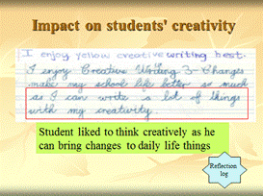 | 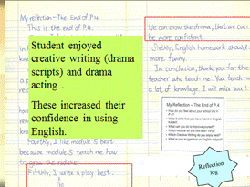
Another student enjoyed writing drama scripts and drama acting. The learning experiences increased their confidence in using English.
Another objective of the project was to improve students’ writing skills.
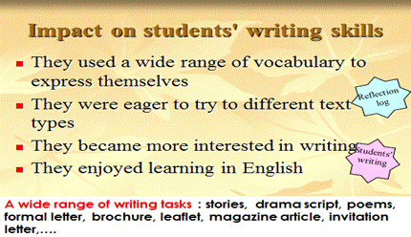
Students had ample opportunities to write different text types. With sufficient language input and rich feedback, students were able to improve their writing skills. In the student writing and the reflection logs, it was also found that the students used a wide range of vocabulary to express themselves, were eager to try to write various text types, developed more interest in writing, and they enjoyed learning in English.

Implications
Throughout the project, the teachers faced some difficulties such as limited time to teach readers and textbook passages to prepare students to attempt several writing tasks in the teaching units. With appropriate adjustment to the content in other aspects of the curriculum, they could finish the target writing tasks.
With systematic infusion of creativity into the tasks, the students got used to thinking creatively. For example, acting in drama (e.g. magnifying a story by adding new characters, places, weather); thinking from other perspectives (e.g. reversing the roles: designer vs buyer in a perfume promotion task); exploring different ideas of growing different plants (e.g. adapting the knowledge learned from General Studies to grow plants).
The students were able to plan for a better self by identifying their own weaknesses or problems and suggest actions to make changes. Thus the students were empowered to think, express, communicate and work on problems creatively in their study and daily lives.
Besides, the students also improved their language skills especially writing skills when they were exposed to a wide variety of genres and practised writing many text types with appropriate format and style in the year.
On the whole, the following actions can be shared with teachers who would like to incorporate creative thinking into their English writing curriculum:-
- Assign writing on a variety of text types in each module using a thematic approach;
- When setting writing tasks, use tools like SCAMPER to help students think creatively about a wide range of topics;
- Set multiple contexts and identify a range of roles in the writing tasks to maximise the use of SCAMPER.

References

References
Curriculum Development Council (2004). The English Language Curriculum Guide, Primary 1-6. Hong Kong: Author.
Curriculum Development Institute, Education Bureau (2012). Nurturing Pupils’ Creative Thinking in the Upper Primary English Classroom. Hong Kong: Author.
Eberle, R. F. (1977). SCAMPER. Buffalo, NewYork: DOK.
Eberle, R. F. (1996). SCAMPER [Reissue]. Waco, TX: Prufrock Press.
Kaufman, J.C. & Baer, J. (eds.) (2006). Creativity and Reason in Cognitive Development. Cambridge: Cambridge University Press.
Excerpt available:
http://assets.cambridge.org/97805218/43850/excerpt/9780521843850_excerpt.pdf
Ofsted (2010). Survey Report: Learning: Creative Approaches that Raise Standards
Report. Accessed on 7 Jun 2013. Available on
http://www.ofsted.gov.uk/resources/learning-creative-approaches-raise-standards
Osborn, A. F. (1953) Applied Imagination: Principles and Procedures of Creative thinking. New York: Scribner.
Weisberg, R. W. (1999) Creativity and knowledge: a Challenge to Theories.In Sternberg, R. J (Ed.) (1999) Handbook of Creativity Cambridge, Cambridge University Press. pp. 226-250.
Acknowledgements
St. Anthony’s School
Ms Whitney Chan
Ms Emily Lam
Mr. William Lee
Ms Kwan Kin Ping

